|  |
| --- |
| **CI/CD Deployment for Springboot Application.**  **By**  **ANANT KHAIRNAR** |

**Date of Submission: 22 -NOV -2023**

**Source code Git Locatio**

**https://github.com/anantkhairnar/CI-CD-Deployment-for-Springboot-Application.git**

**Screen shot**

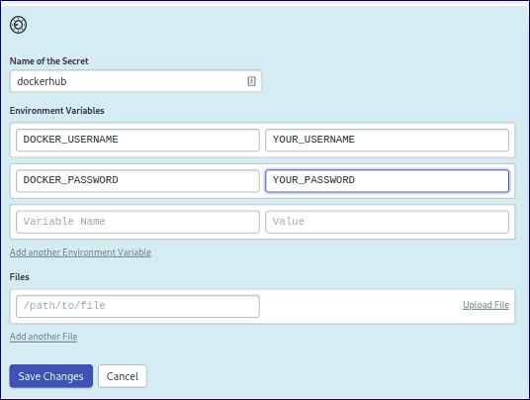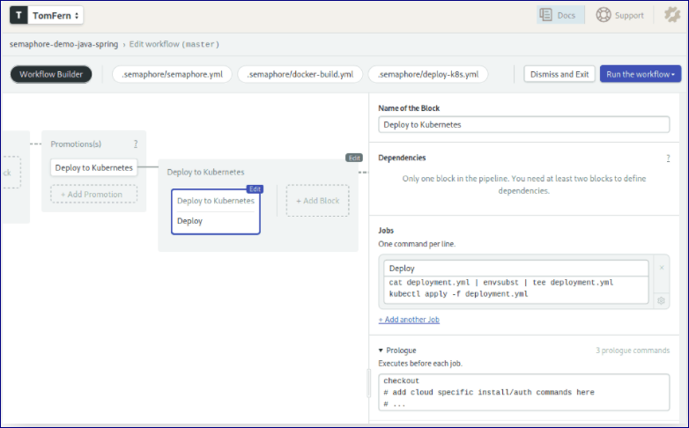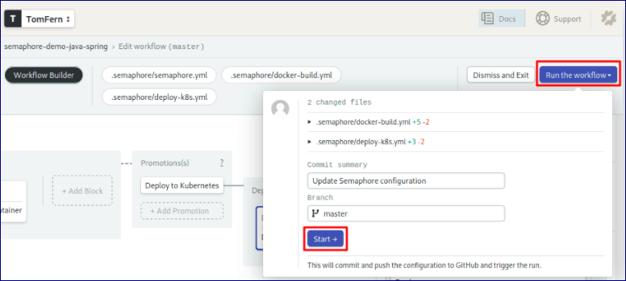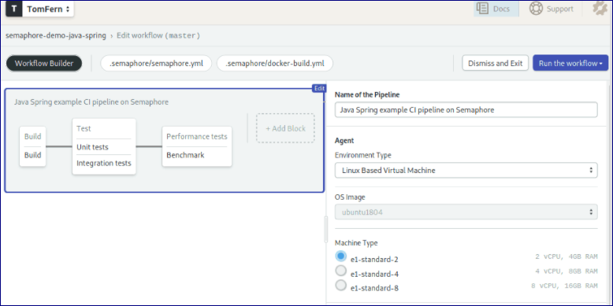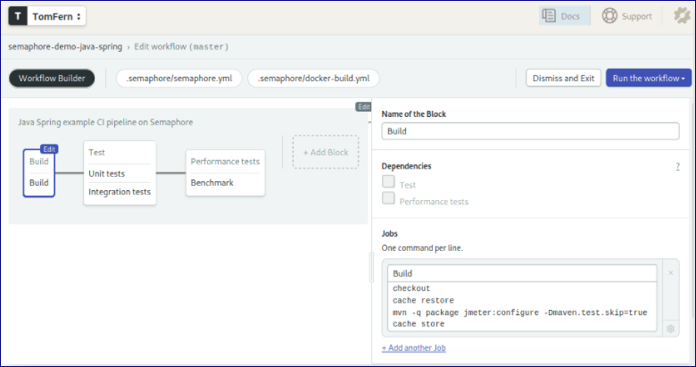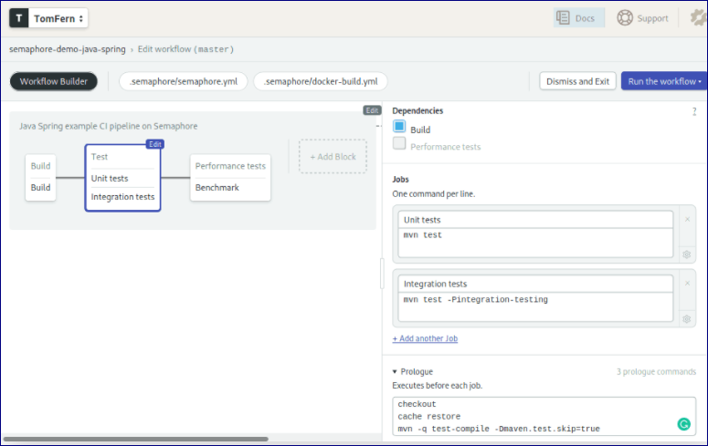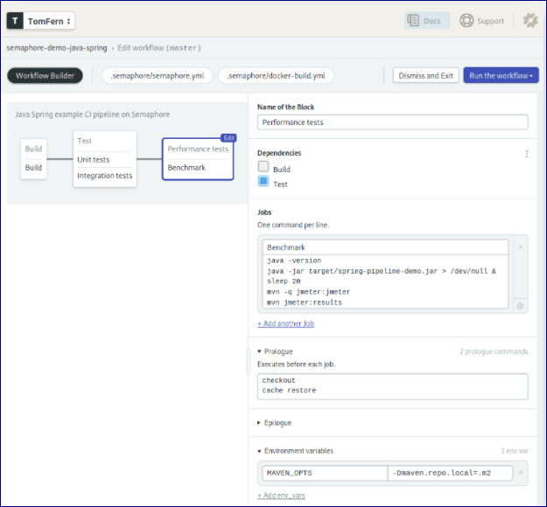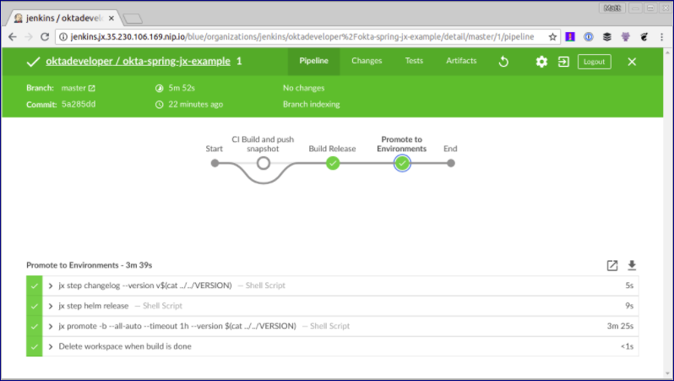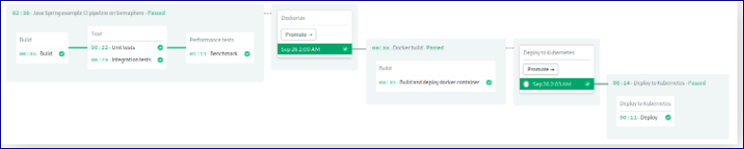

|  |
| --- |
| **Screen Shots:** |
|  |
|  |
|  |
|  |
|  |
|  |
|  |
|  |
|  |
|  |
|  |
|  |
|  |
|  |
|  |
|  |
|  |
|  |